Missing Video Issue – Scenario 2: Corrupted Video File in Bucket
Issue Description
For OTV channel, data for 17 June 2026, 06:30 AM – 06:40 AM was missing on the frontend.
Upon investigation, it was found that:
- The video available in CDAPI was correct.
- The video stored in the Google Cloud Storage bucket was corrupted.
- After downloading the video from the bucket and attempting to play it, an error was encountered indicating that the file was corrupted.
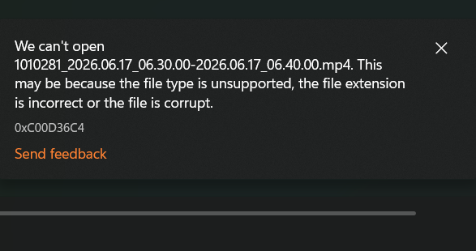

Resolution Steps
Step 1: Verify the Video in the Bucket
- Open the Google Cloud Console.
- Navigate to:
Cloud Storage → Bucket Details → imagestg-bucket-qa
Bucket URL: imagestg-bucket-qa – Bucket details – Cloud Storage – tabsons – Google Cloud console
- Locate the video corresponding to the affected time slot.
- Download the video and verify it by playing it locally.
- Confirm that the video is corrupted.
- Delete the corrupted video from the bucket.
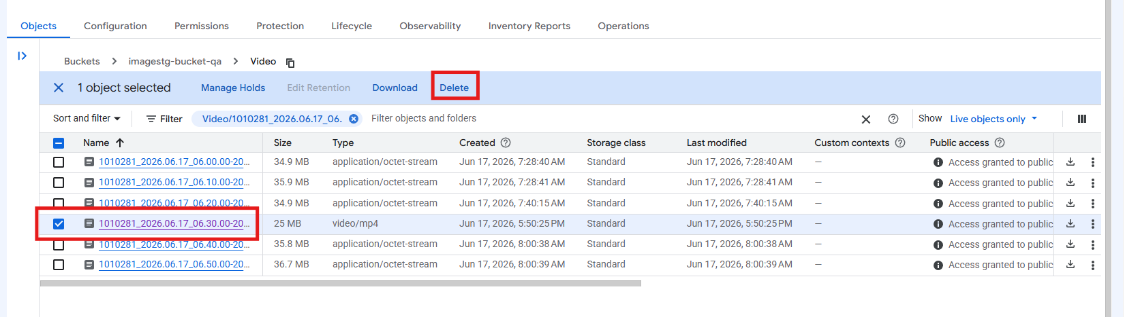

Step 2: Download the Correct Video from CDAPI
CDAPI Details
- URL: Logger
- Username: gyana
- Password: password
- Log in to CDAPI.
- Search for the affected channel and date/time.
- Verify that the video is available and playable.
- Download the required video clip (1-hour recording).
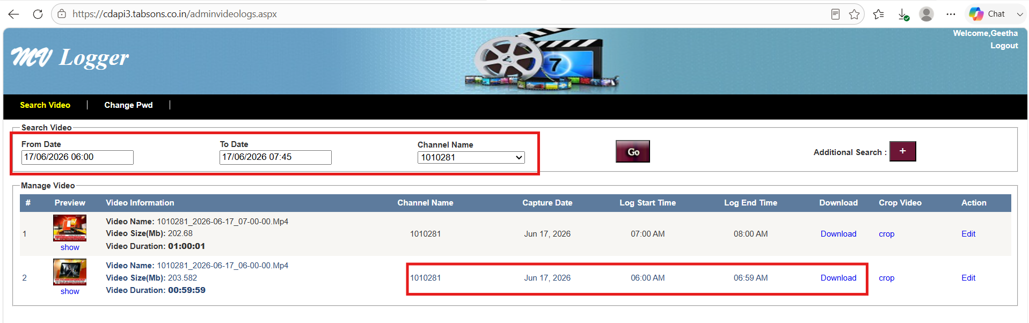

Step 3: Prepare the Video for Splitting
- Place the downloaded 1-hour video inside the video folder used by the Python script.
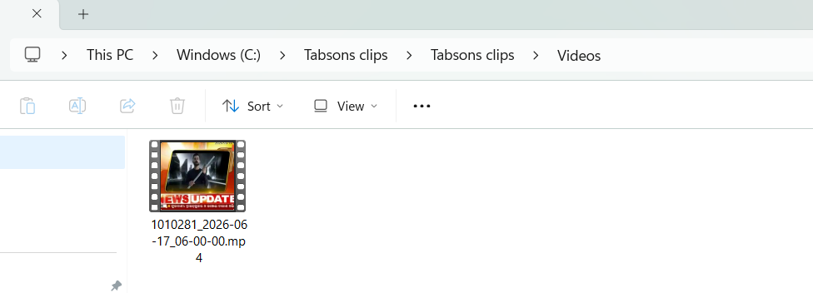

Step 4: Execute the Video Splitting Script
- Open the folder containing the Python script.
- In the folder path bar, type:
- Cmd
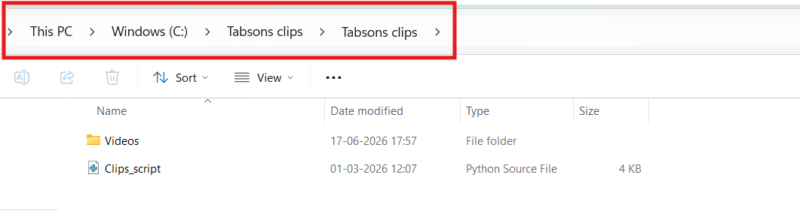
- Press Enter to open Command Prompt at that location.
- Execute the following command:
- python Clips_script.py
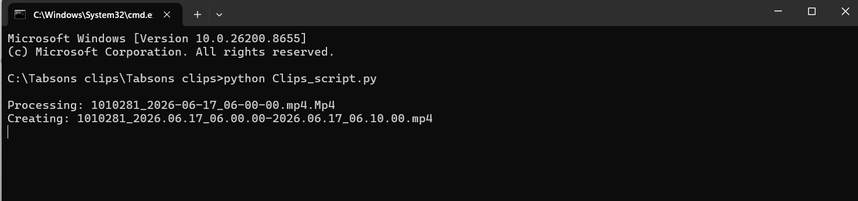
- Wait for the script to complete execution.
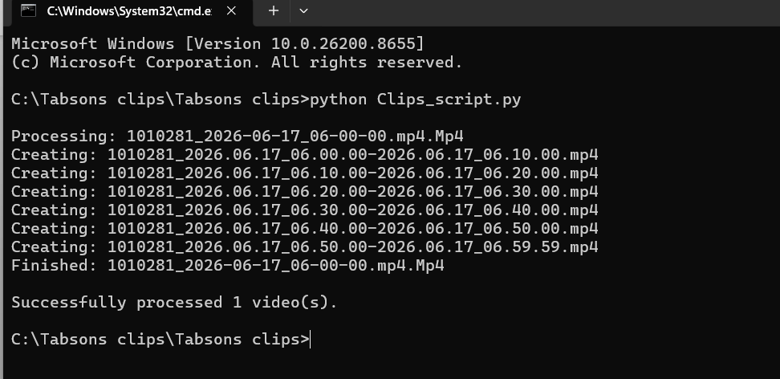

Step 5: Verify Generated Clips
- After successful execution, the script will split the 1-hour video into multiple 10-minute clips.
- Confirm that all clips are generated successfully inside the video folder.
- Verify that the affected clip is playable.
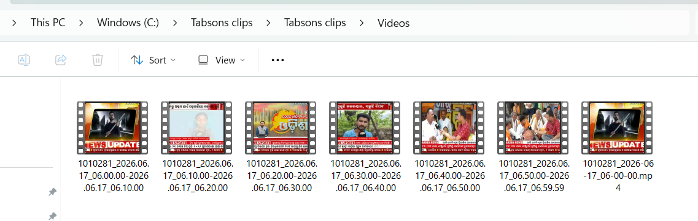

Step 6: Upload the Correct Clips to the Bucket
- Open the imagestg-bucket-qa bucket.
- Navigate to the Video folder.
- Upload the newly generated video clips.
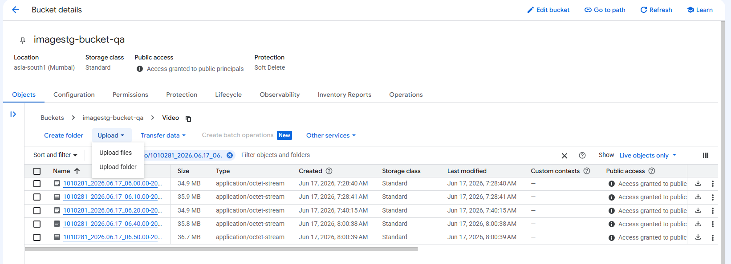
- Ensure that the upload completes successfully.
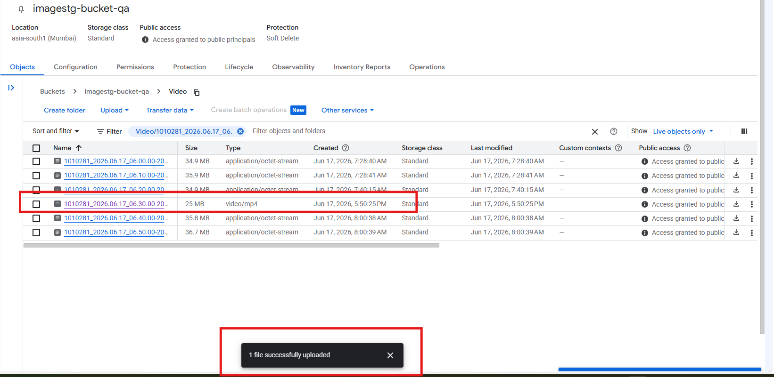

Step 7: Verify on Frontend
- Refresh the frontend page.
- Open the affected date and time slot.
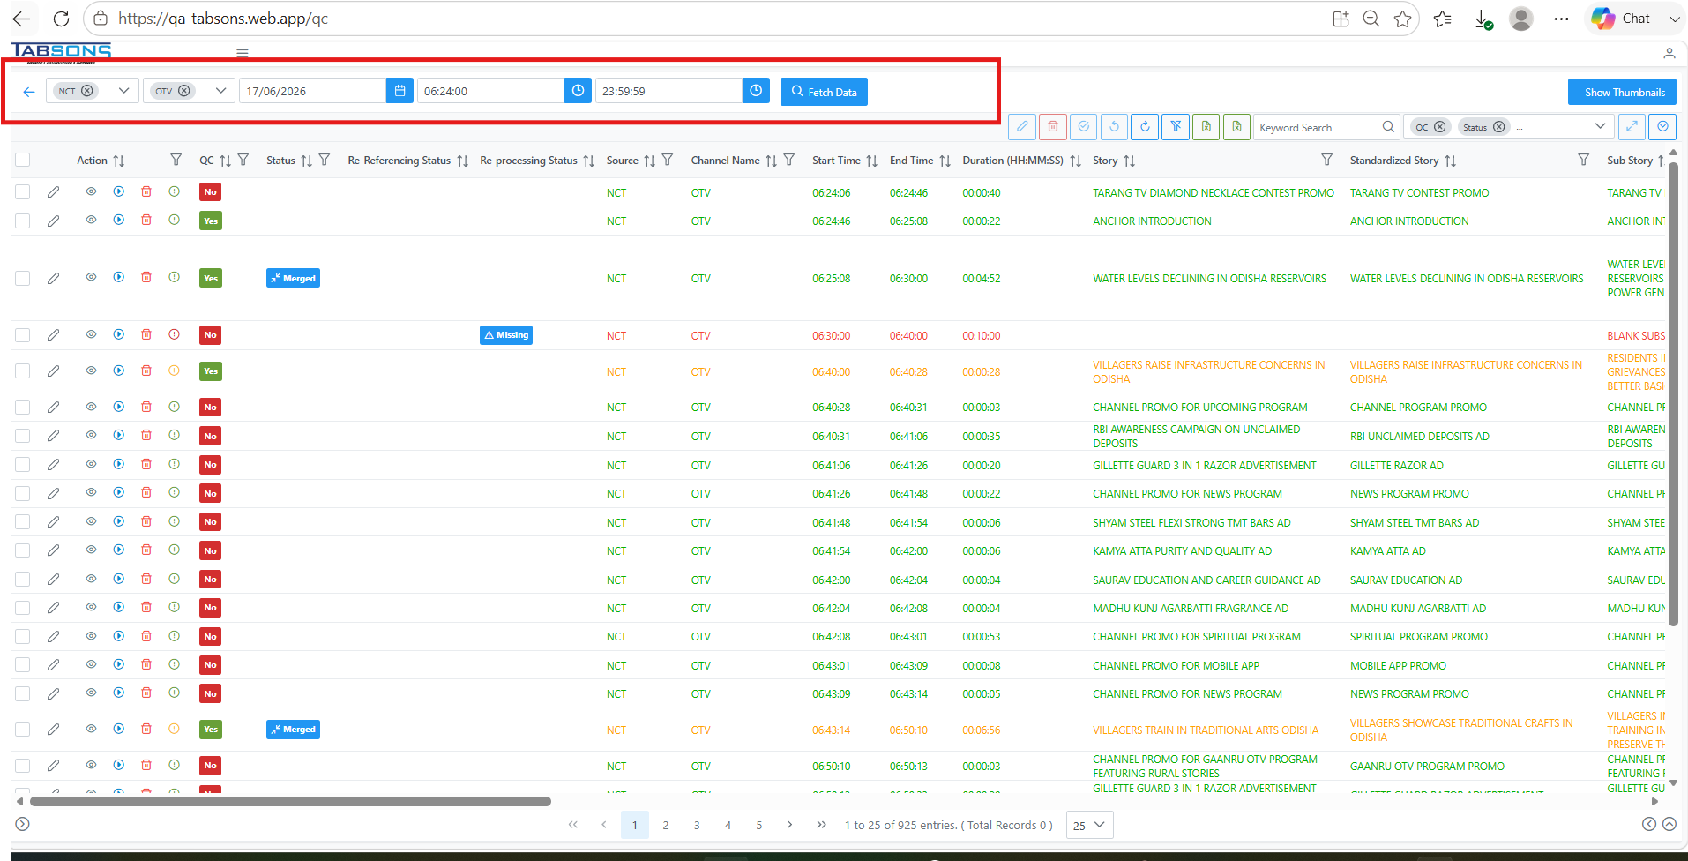
- Verify that the video is now playing correctly and the missing data issue has been resolved.
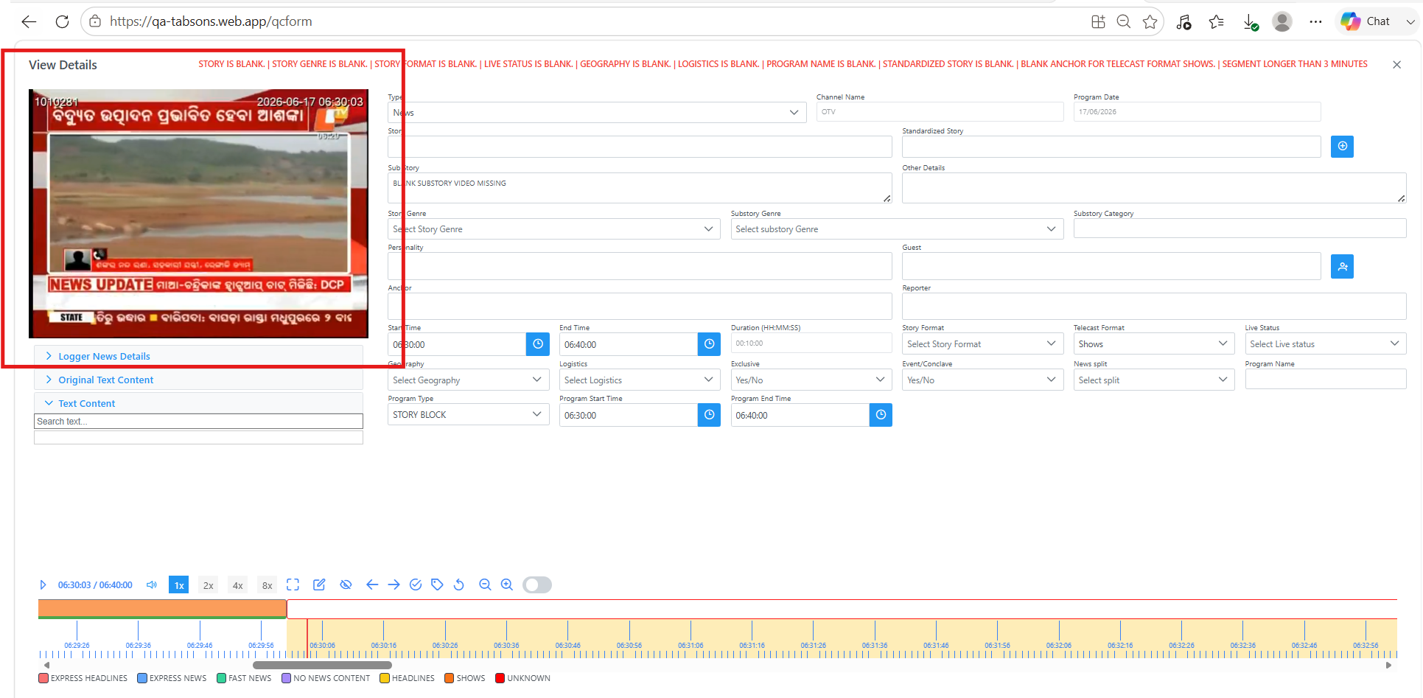

Root Cause
The issue occurred because the video stored in the Google Cloud Storage bucket was corrupted, while the source video available in CDAPI was intact.

